**Student 1:**

**Name: أسماء جمال عبد الحليم مبروك ناجي**

**ID: 15010473**

**Student2:**

**Name: خلود مسعد محمد الطايفى**

**ID: 18010614**

**Final Project – Biomedical Engineering  
1.Ecg signal:**

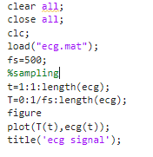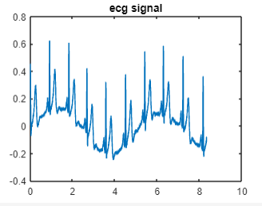

**The signal has been sampled with a frequency of 500 Hz**

**set frequencies below 0.5 Hz to zero:**

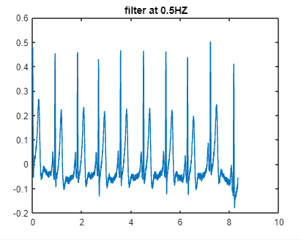

**2.Notch filter at 50HZ** 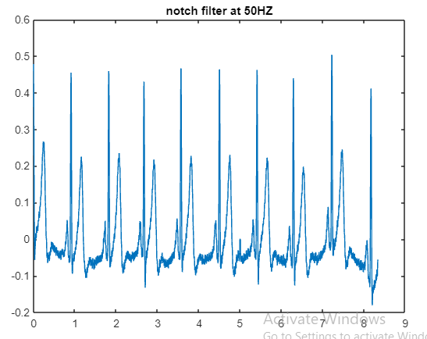

**3.** **Increasing the signal-to-noise ratio:**

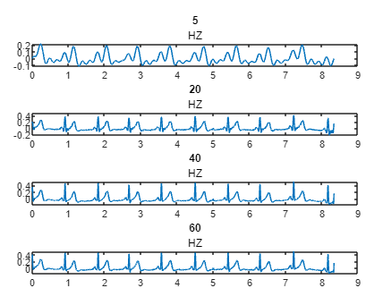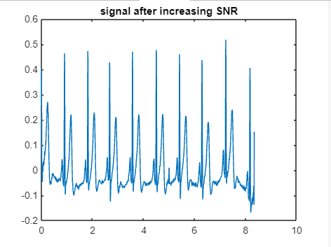

**A higher bandwidth will give more noise in the signals,**

**and limiting the bandwidth can obscure details in the ECG**.

**a compromise on the cutt f freq we choose 5.99(50) almost 6 HZ filter**

**to not details in the ecg without give more noise.**

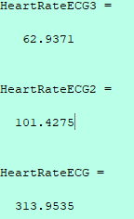**4. Finding the heart rate using autocorrelation:  
The processed signal has less heart rate than the unprocessed signal.**

HeartRateECG = 313.9535

HeartRateECG2 = 101.4275

HeartRateECG3 = 62.9371

1. **Ecg:**

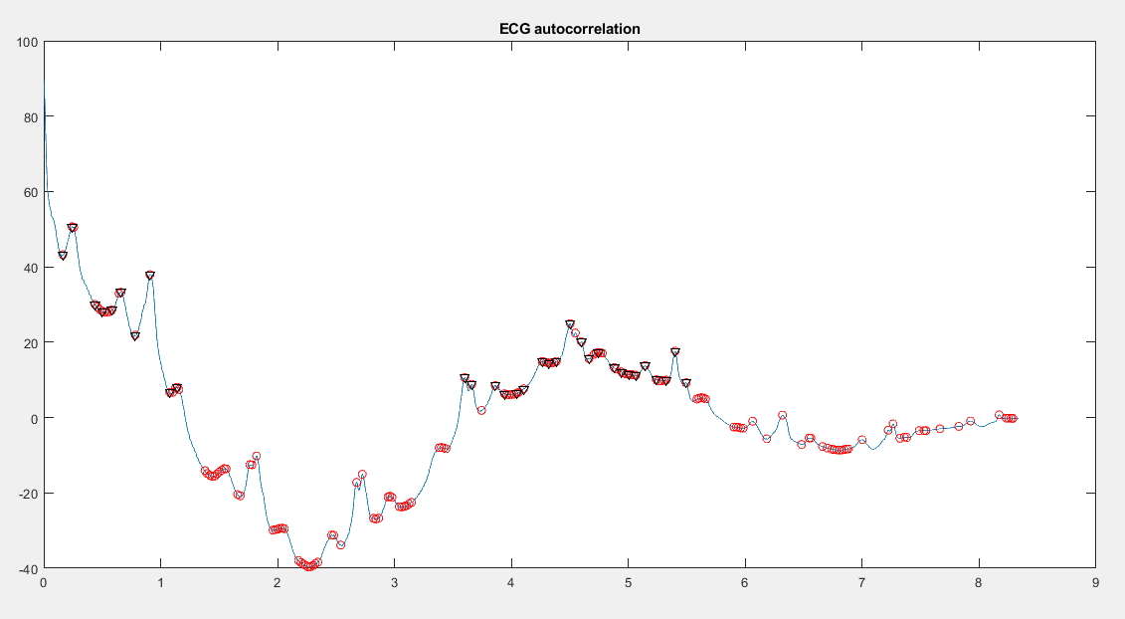

1. **Ecg2:**

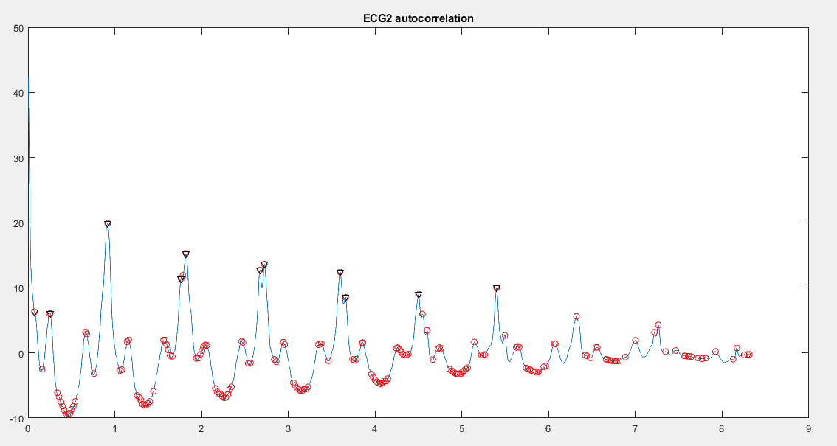

1. **Ecg3:**

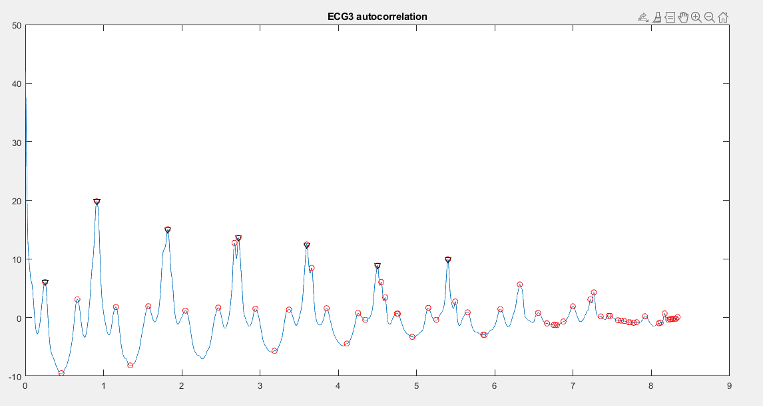

**The autocorrelation heart rate code:**

%% Asmaa's part

%-------- 4. Finding the heart rate using autocorrelation -----------------

AdultRate=90;

%ecg3

figure (6)

ecg3norm = ecg3 - mean(ecg3);

[autocor,lags] = xcorr(ecg3norm,ecg3norm);

autocor=autocor(round(length(autocor)/2):end);

lags=lags(round(length(lags)/2):end);

[peakShort,locationShort] = findpeaks(autocor);

short = mean(diff(locationShort))/fs;

[RRpeak,locationR] = findpeaks(autocor,'MinPeakDistance',ceil(short*fs),'MinPeakheight',6);

RRinterval = mean(diff(locationR))/(0.6*fs);

HeartRateECG3=AdultRate/RRinterval

plot(lags/fs,autocor);

hold on

plot(lags(locationShort)/fs,peakShort,'or', lags(locationR)/fs,RRpeak,'vk');

title('ECG3 autocorrelation')

%ecg2

figure (7)

ecg2norm = ecg2 - mean(ecg2);

[autocor,lags] = xcorr(ecg2norm,ecg2norm);

autocor=autocor(round(length(autocor)/2):end);

lags=lags(round(length(lags)/2):end);

[peakShort,locationShort] = findpeaks(autocor);

short = mean(diff(locationShort))/fs;

[RRpeak,locationR] = findpeaks(autocor,'MinPeakDistance',ceil(short*fs),'MinPeakheight',6);

RRinterval = mean(diff(locationR))/(0.6*fs);

HeartRateECG2=AdultRate/RRinterval

plot(lags/fs,autocor);

hold on

plot(lags(locationShort)/fs,peakShort,'or', lags(locationR)/fs,RRpeak,'vk');

title('ECG2 autocorrelation')

%ecg

figure (8)

ecgnorm = ecg - mean(ecg);

[autocor,lags] = xcorr(ecgnorm,ecgnorm);

autocor=autocor(round(length(autocor)/2):end);

lags=lags(round(length(lags)/2):end);

[peakShort,locationShort] = findpeaks(autocor);

short = mean(diff(locationShort))/fs;

[RRpeak,locationR] = findpeaks(autocor,'MinPeakDistance',ceil(short*fs),'MinPeakheight',6);

RRinterval = mean(diff(locationR))/(0.6*fs);

HeartRateECG=AdultRate/RRinterval

plot(lags/fs,autocor);

hold on

plot(lags(locationShort)/fs,peakShort,'or', lags(locationR)/fs,RRpeak,'vk');

title('ECG autocorrelation')

**5. Finding the QRS complex:**

1. **Ecg:**

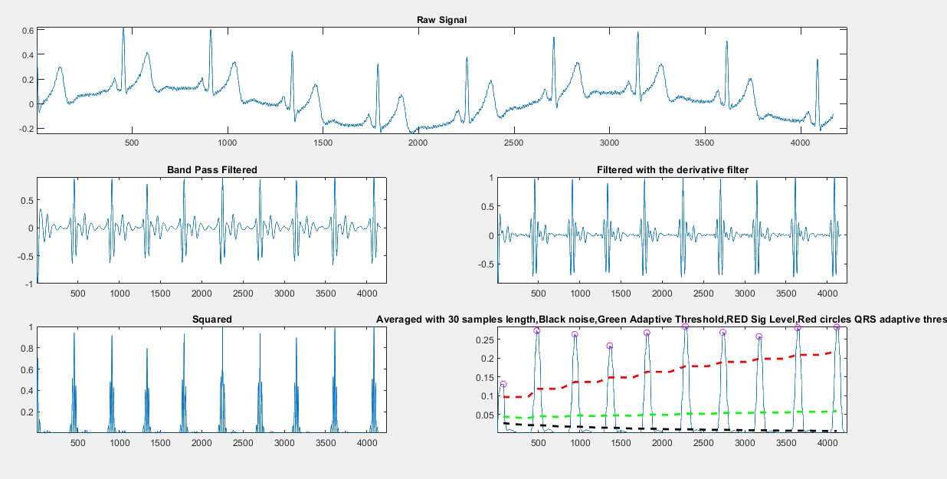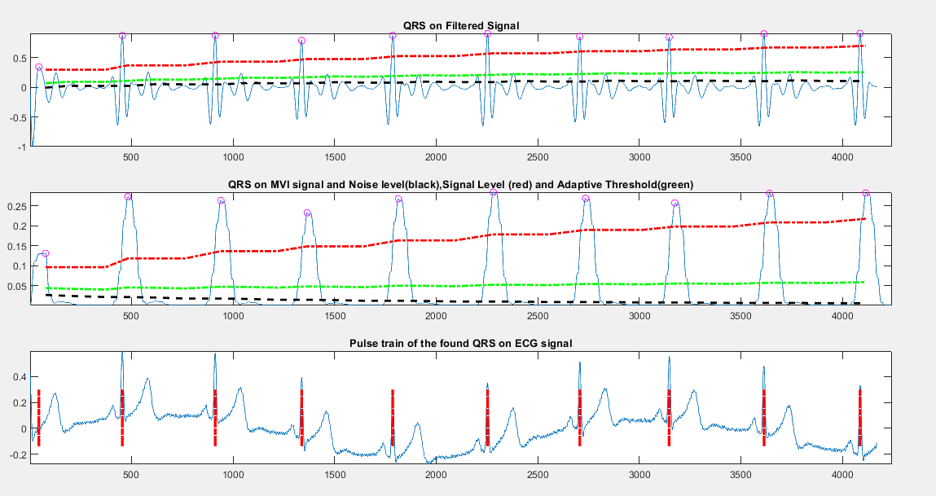

1. **Ecg2:**

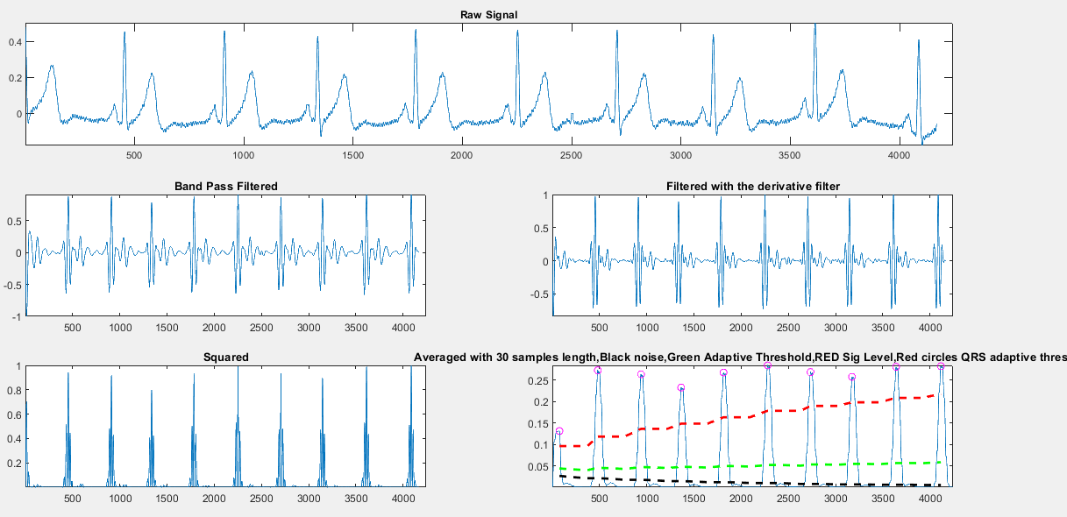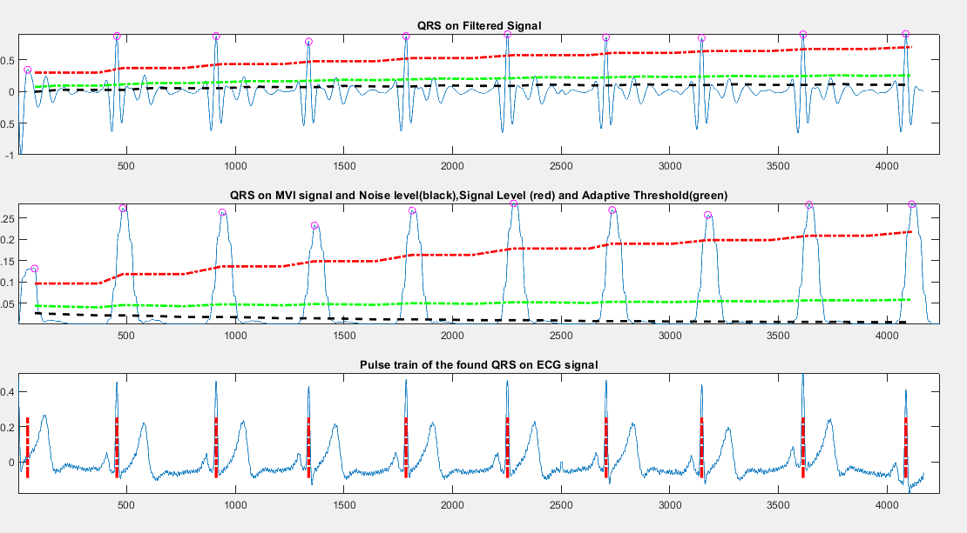

1. **Ecg3:**

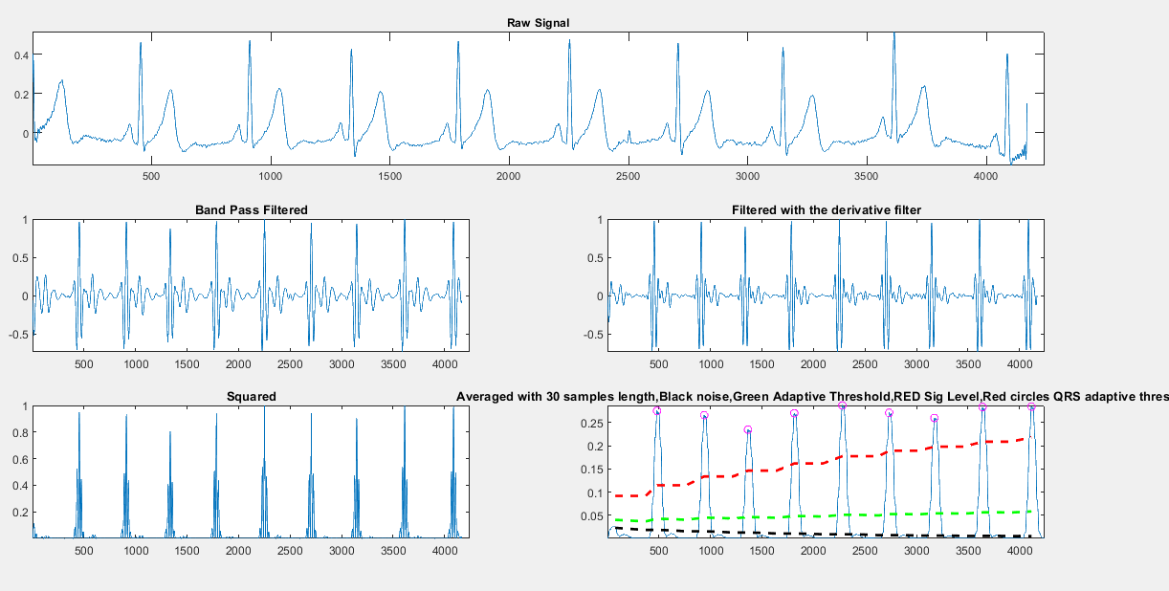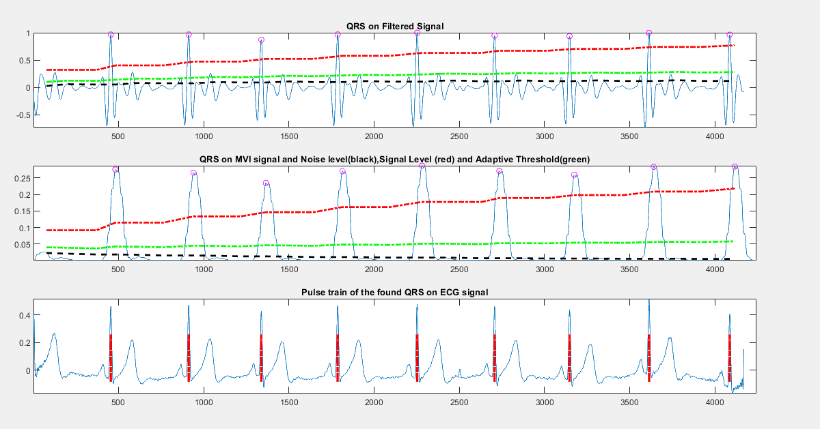

**The QRS code:**

%% conintuing of Asmaa's part

%-------- 5. Finding the QRS complex: -----------------

figure ;

pan_tompkin(ecg, fs,1);

figure;

pan_tompkin(ecg2, fs,1);

figure;

pan_tompkin(ecg3, fs,1);

%{

%%%%%%%%%%%%%%%%%%%%%%%%%%%%%%% the detailed solution with steps %%%%%%%%%%%

if ~isvector(ecg)

error('ecg must be a row or column vector');

end

gr = 1; % on default the function always plots

ecg = ecg(:); % vectorize

% ======================= Initialize =============================== %

delay = 0;

skip = 0; % becomes one when a T wave is detected

m_selected_RR = 0;

mean_RR = 0;

ser_back = 0;

ax = zeros(1,6);

% ============ Noise cancelation(Filtering)( 5-15 Hz) =============== %%

if fs == 200

% ------------------ remove the mean of Signal -----------------------%

ecg = ecg - mean(ecg);

% ==== Low Pass Filter H(z) = ((1 - z^(-6))^2)/(1 - z^(-1))^2 ==== %%

Wn = 12*2/fs;

N = 3; % order of 3 less processing

[a,b] = butter(N,Wn,'low'); % bandpass filtering

ecg_l = filtfilt(a,b,ecg);

ecg_l = ecg_l/ max(abs(ecg_l));

% ======================= start figure ============================= %%

figure;

ax(1) = subplot(321);plot(ecg);axis tight;title('Raw signal');

ax(2)=subplot(322);plot(ecg_l);axis tight;title('Low pass filtered');

% ==== High Pass filter H(z) = (-1+32z^(-16)+z^(-32))/(1+z^(-1)) ==== %%

Wn = 5*2/fs;

N = 3; % order of 3 less processing

[a,b] = butter(N,Wn,'high'); % bandpass filtering

ecg_h = filtfilt(a,b,ecg_l);

ecg_h = ecg_h/ max(abs(ecg_h));

ax(3)=subplot(323);plot(ecg_h);axis tight;title('High Pass Filtered');

else

% bandpass filter for Noise cancelation of other sampling frequencies(Filtering)

f1=5; % cuttoff low frequency to get rid of baseline wander

f2=15; % cuttoff frequency to discard high frequency noise

Wn=[f1 f2]*2/fs; % cutt off based on fs

N = 3; % order of 3 less processing

[a,b] = butter(N,Wn); % bandpass filtering

ecg_h = filtfilt(a,b,ecg);

ecg_h = ecg_h/ max( abs(ecg_h));

ax(1) = subplot(3,2,[1 2]);plot(ecg);axis tight;title('Raw Signal');

ax(3)=subplot(323);plot(ecg_h);axis tight;title('Band Pass Filtered');

end

% ==================== derivative filter ========================== %%

% ------ H(z) = (1/8T)(-z^(-2) - 2z^(-1) + 2z + z^(2)) --------- %

if fs ~= 200

int_c = (5-1)/(fs*1/40);

b = interp1(1:5,[1 2 0 -2 -1].*(1/8)*fs,1:int_c:5);

else

b = [1 2 0 -2 -1].*(1/8)*fs;

end

ecg_d = filtfilt(b,1,ecg_h);

ecg_d = ecg_d/max(ecg_d);

ax(4)=subplot(324);plot(ecg_d);

axis tight;

title('Filtered with the derivative filter');

% ========== Squaring nonlinearly enhance the dominant peaks ========== %%

ecg_s = ecg_d.^2;

ax(5)=subplot(325);

plot(ecg_s);

axis tight;

title('Squared');

%============ Moving average ================== %%

%-------Y(nt) = (1/N)[x(nT-(N - 1)T)+ x(nT - (N - 2)T)+...+x(nT)]---------%

ecg_m = conv(ecg_s ,ones(1 ,round(0.150*fs))/round(0.150*fs));

delay = delay + round(0.150*fs)/2;

ax(6)=subplot(326);plot(ecg_m);

axis tight;

title('Averaged with 30 samples length,Black noise,Green Adaptive Threshold,RED Sig Level,Red circles QRS adaptive threshold');

axis tight;

%}

**6. ECG heart diseases Survey With Figures:**

[**Brugada Syndrome**](https://www.melbourneheartrhythm.com.au/learn/conditions/52-brugada-syndrome)

Brugada Syndrome is a rare inherited cardiac arrhythmia syndrome that is characteristed by a 'coved-shaped' atypical right bundle branchpattern on a 12-lead ECG (Type-1 Brugada pattern ECG) and is associated with ventricular arrhythmias and sudden cardiac death.  Brugada Syndrome is reported to be responsible for 4% of all sudden deaths and 20% of sudden deaths in those without structural heart disease.

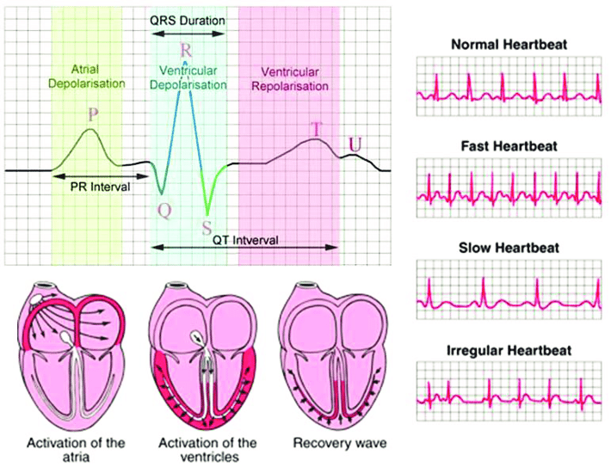

# [Ventricular Tachycardia in Structural Heart Disease](https://melbourneheartrhythm.com.au/learn/conditions/78-ventricular-tachycardia-in-structural-heart-disease)

